**EXPERIMENT 2 Date: 20th January 2023**

**TITLE:** **DML (Data Manipulation Language) commands**

**Objective:** To understand the concept of different DML commands.

1. **EXERCISE ON RETRIEVING RECORDS FROM A TABLE.**
2. **Find out the names of all the clients.**

* SELECT NAME FROM CLIENT_MASTER;

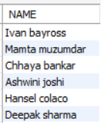

1. **Retrieve the entire contents of the Client_Master table.**

* SELECT NAME FROM CLIENT_MASTER;

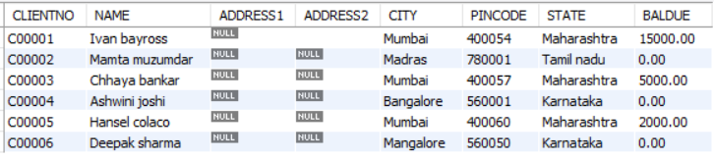

1. **Retrieve the list of names, city and the state of all the clients.**

* SELECT NAME, CITY, STATE FROM CLIENT_MASTER;

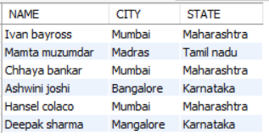

1. **List the various products available from the Product_Master table.**

* SELECT DESCRIPTION FROM PRODUCT_MASTER;

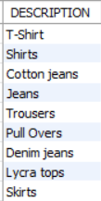

1. **List all the clients who are located in Mumbai.**

* SELECT NAME FROM CLIENT_MASTER WHERE CITY="MUMBAI";

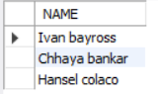

1. **Find the names of salesman who have a salary equal to Rs.3000.**

* SELECT SALESMANNAME FROM SALESMAN_MASTER WHERE SALAMT="3000";

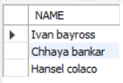

1. **EXERCISE ON UPDATING RECORDS IN A TABLE**
   1. **Change the city of ClientNo ‘C00005’ to ‘Bangalore’.**

* UPDATE CLIENT_MASTER SET CITY = "BANGALORE" WHERE CLIENTNO = "C00005";
* SELECT CLIENTNO, CITY FROM CLIENT_MASTER WHERE CLIENTNO = "C00005";



* 1. **Change the BalDue of ClientNo ‘C00001’ to Rs.1000.**
* UPDATE CLIENT_MASTER SET BALDUE = "1000" WHERE CLIENTNO = "C00001";
* SELECT CLIENTNO, BALDUE FROM CLIENT_MASTER WHERE CLIENTNO = "C00001";



* 1. **Change the cost price of ‘Trousers’ to Rs.950.00.**
* UPDATE PRODUCT_MASTER SET COST_PRICE = "950" WHERE DESCRIPTION = "TROUSERS";
* SELECT DESCRIPTION, COST_PRICE FROM PRODUCT_MASTER WHERE DESCRIPTION = "TROUSERS";



* 1. **Change the city of the salesman to Pune.**
* UPDATE SALESMAN_MASTER SET CITY = "PUNE";
* SELECT * FROM SALESMAN_MASTER;

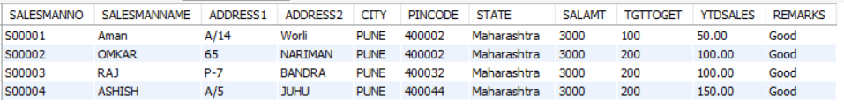

1. **EXERCISE ON DELETING RECORDS IN A TABLE**
2. **Delete all salesman from the Salesman_Master whose salaries are equal to Rs.3500.**

* DELETE FROM SALESMAN_MASTER WHERE SALAMT=3500;
* SELECT * FROM SALESMAN_MASTER;

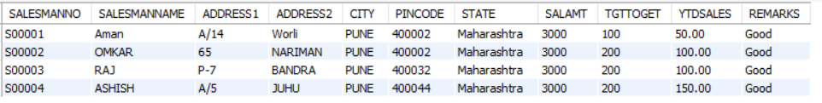

1. **Delete all products from Product_Master where the quantity on hand is equal to 100.**

* DELETE FROM PRODUCT_MASTER WHERE QTY_ON_HAND=100;
* SELECT * FROM PRODUCT_MASTER;

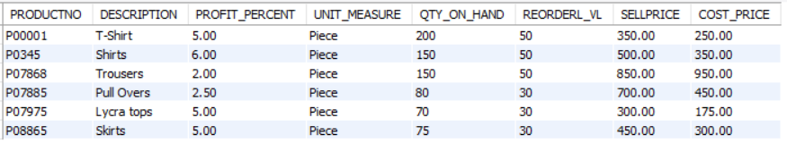

1. **Delete from Client_Master where the column state holds the value ‘Tamil Nadu’.**

* DELETE FROM CLIENT_MASTER WHERE STATE="TAMIL NADU";
* SELECT * FROM CLIENT_MASTER;

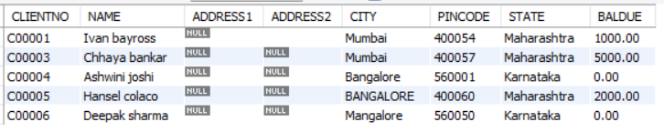

1. **EXERCISE ON ALTERING THE TABLE STRUCTURE**
   1. **Add a column called ‘Telephone’ of data type integer to the Client_Master table.**

* ALTER TABLE CLIENT_MASTER ADD TELEPHONE INTEGER;
* DESC CLIENT_MASTER;

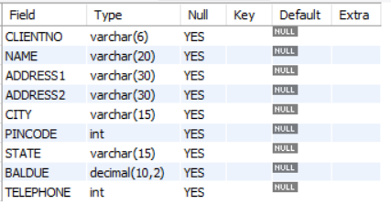

* 1. **Change the size of SellPrice column in Product _Master to (10, 2).**
* ALTER TABLE PRODUCT_MASTER MODIFY SELLPRICE DECIMAL(10,2);
* DESC PRODUCT_MASTER;

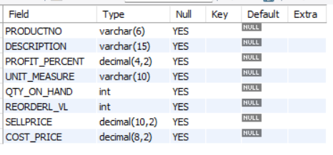

1. **EXERCISE ON DELETING THE TABLE STRUCTURE ALONG WITH THE DATA**
   1. **Destroy the table Client_Master along with its data.**

* DROP TABLE CLIENT_MASTER;
* SHOW TABLES;

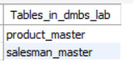

1. **EXERCISE ON RENAMING THE TABLE**
   1. **Change the name of the Salesman_Master to sman_mast.**

* ALTER TABLE SALESMAN_MASTER RENAME TO SMAN_MAST;
* SHOW TABLES;

